

KARANATAKA STATE OPEN UNIVERSITY

DIPLOMA IN MECHANICAL ENGINEERING

SEMESTER SYSTEM

SYLLABUS

I YEAR SYLLBUS

(Basic Engineering)
(Common to all Branches)

Subject Code | Subject Title | Max Marks | Max Credits
Semester-I
BE101 | Communication English | 100 | 4
BE102 | Applied Mathematics-1 | 100 | 4
BE103 | Engineering Physics-I | 100 | 4
BE104 | Engineering Chemistry-I | 100 | 4
BE105 | Computer Application Lab | 100 | 2
BE106 | Workshop Practice Lab | 100 | 2
Semester -II
BE201 | Applied Mathematics-1I | 100 | 4
BE202 | Engineering Physics-II | 100 | 4
BE203 | Engineering Chemistry-II | 100 | 4
BE204 | Engineering Graphics | 100 | 4
BE205 | Physics Lab | 100 | 2
BE206 | Chemistry Lab | 100 | 2

Mechanical Engineering
III Semester

Subject Code | Subject Title | Max Marks | Max Credits
ME 301 | Engineering Mechanics | 100 | 4
ME 302 | Manufacturing Technology-I | 100 | 4
ME 303 | Fluid Mechanics | 100 | 4
ME 304 | Machine Drawing | 100 | 4
ME 305 | Engineering Mechanics Lab | 100 | 2
ME 306 | Workshop-I | 100 | 2

IV Semester

Subject Code | Subject Title | Max Marks | Max Credits
ME 401 | Thermodynamics | 100 | 4
ME 402 | Manufacturing Technology-II | 100 | 4
ME 403 | Electrical and Electronics Engineering | 100 | 4
ME 404 | Refrigeration and Air Conditioning | 100 | 4
ME 405 | Thermodynamics Lab | 100 | 2
ME 406 | Workshop-II | 100 | 2

V Semester

Subject Code | Subject Title | Max Marks | Max Credits
ME 501 | Design of Machine Elements | 100 | 4
ME 502 | Thermal Engineering | 100 | 4
ME 503 | Metrology | 100 | 4
ME 504 | Mechatronics | 100 | 4
ME 505 | Metrology Lab | 100 | 2
ME 506 | Workshop-III | 100 | 2

VI Semester

Subject Code | Subject Title | Max Marks | Max Credits
ME 601 | Industrial Engineering and Management | 100 | 4
ME 602 | CAD/CAM | 100 | 4
ME 603 | Automobile Technology | 100 | 4
ME 604 | CAD/CAM Lab | 100 | 2
ME 605 | Project | 400 | 8

Total Marks = 3800
Total Credits = 122

SEMESTER : I

Subject Code : BE 101

Subject Title : Communication English

Structure of the Course Content

BLOCK 1 Grammar (Non-Textual)
Unit 1: Functional Analysis
Unit 2: Voice and parts of speech
Unit 3: Direct and indirect speech
Unit 4: Preposition

BLOCK 2 Grammar
Unit 1: One word substitute
Unit 2: Articles and question tags
Unit 3: Prefixes and suffixes
Unit 4: Tenses

BLOCK 3 Composition
Unit 1: Comprehension
Unit 2: Simple passage
Unit 3: Moral story
Unit 4: Science and technology

BLOCK 4 Letter and dialogue Writing
Unit 1: Letter writing - personal
Unit 2: Letter writing - official
Unit 3: Dialogue writing
Unit 4: Hints development

BLOCK 5 Prose
Unit 1: An Astrloger's day – R.K. Narayanan
Unit 2: The sun, The planets and the stars – C.Jones
Unit 3: The continuing spell of Ramanujam
Unit 4: On saying 'please' – A.G.Gardiner

Books :
- A.S.Hornby, 'The advanced learners Dictionary of current English', Oxford university press.
- Longman Basic English dictionary Ist Edition Pearson Longman

SEMESTER : I

Subject Code : BE 102

Subject Title : Applied Mathematics - I

Structure of the Course Content

BLOCK 1 Algebra
Unit 1: Determinants
Unit 2: Matrices
Unit 3: Permutation and combination
Unit 4: Binomial Theorem

BLOCK 2 Complex numbers
Unit 1: Real and imaginary parts
Unit 2: Demoivre's Theorem
Unit 3: Finding the n ^{th} roots of unity
Unit 4: Solving equations

BLOCK 3 Analytical geometry
Unit 1: Pair of straight lines
Unit 2: Circles
Unit 3: Family of circles
Unit 4: Concentric circles

BLOCK 4 Trignometry
Unit 1: Compound angles
Unit 2: Multiple angles
Unit 3: Sub multiple angles
Unit 4: Sum and product formulae

BLOCK 5 Differential calculas
Unit 1: Limits
Unit 2: Differentiation
Unit 3: Differentiation methods
Unit 4: Successive differentiation

Books :

1. Engineering Mathematics – Dr M.K.Venkatraman, National Publishing Co.
2. Engineering Mathematics – Dr P.Kandasamy, Schand & Co

SEMESTER : I

Subject Code : BE 103

Subject Title : Engineering Physics - I

Structure of the Course Content

BLOCK 1 S I units and Statics
Unit 1: Fundamental quantities
Unit 2: Derived quantities
Unit 3: Concurrent forces
Unit 4: parallelogram Law of forces

BLOCK 2 Properties of matter
Unit 1: Stress and strain
Unit 2: Young's modulus
Unit 3: Viscosity
Unit 4: Surface Tension

BLOCK 3 Dynamics
Unit 1: Projectile Motion
Unit 2: Angle of projection
Unit 3: Circular Motion
Unit 4: Application of circular motion

BLOCK 4 Rotational motion of rigidity bodies
Unit 1: Moment of Inertia
Unit 2: Kinetic energy
Unit 3: Angular Momentum
Unit 4: Kepler's Law

BLOCK 5 Remote sensing and sound
Unit 1: Active and Passive remote sensing
Unit 2: Microwave remote sensing
Unit 3: Types of sound waves
Unit 4: Acoustics

Books :

1.Narayana Kurup – Mechanics – S.Chand publishers
2. B.L.Theraja – Engineering Physics – S.Chand Publishers

SEMESTER : I

Subject Code : BE 104

Subject Title : Applied Chemistry - I

Structure of the Course Content

BLOCK 1 Acids – Bases, Catalysis
Unit 1: Theories of Acids and Bases
Unit 2: Industrial application
Unit 3: Positive and Negative catalyst
Unit 4: Characteristics of Catalyst

BLOCK 2 Pollution
Unit 1: Air Pollution
Unit 2: Global warming
Unit 3: Water Pollution
Unit 4: Green Chemistry

BLOCK 3 Electro chemistry and corrosion
Unit 1: Types of conductors
Unit 2: Industrial applications of Electrochemistry
Unit 3: Electrochemical theory
Unit 4: Electroplating

BLOCK 4 Orgonic coatings
Unit 1: Paint
Unit 2: Varnish
Unit 3: Adhesives
Unit 4: Lubricants

BLOCK 5 Colloids and Ceramics
Unit 1: Colloidal solution
Unit 2: Brownian Movement
Unit 3: Water purification
Unit 4: Ceramics

Books :

1. Jain & Jain – Engineering chemistry – Dhanpatrai & Co
2.Uppal– Engineering Chemistry– Khanna publishers

SEMESTER : I

Subject Code : BE 105
Subject Title : Computer Application Lab

Practicals
Windows
1.a. Starting a program, running a program.
b. Starting the Windows in safe mode
c. Running multiple Programs and switching between windows.
d. Moving the windows, and the task bar.
e. Startup to MS-DOS prompt.
2.a. Creating and removing a folder.
b. Making the taskbar wider, arranging icons on the Desktop.
c. Displaying and hiding the taskbar clock.
d. Controlling the size of start menu options.
e. Creating shortcuts.
3.a. Installing a screen saver.
b. Assigning Wallpaper to Desktop.
c. Adding a program to the start menu.
d. Recovering files and folders from Recycle bin.
e. Customizing the mouse settings.
4 a. Expanding and collapsing a folder.
b. Recognizing file types using icons.
c. Running a program from explorer.
d. Renaming a file or folder.
e. Selecting two or more files for an operation.
5.a. Displaying the properties for a file or folder.
b. Using cut and paste operations to copy a file.
c. Using copy and paste operations to copy a file.
d. Moving and copying files with mouse.
e. Sorting a folder.
6.a. Finding a file or folder, by name.
b. Defragmenting the disk using disk defragmenter.
c. Compressing a file using WinZip.
d. Controlling the speaker volume.
e. Recording and saving an audio file.
MS Word
a. Prepare a newsletter with borders, two columns text, header and footer and a graphic
image and spell check the document.
b. Create a table to show the paradigm of the verb “eat” in all 12 tenses

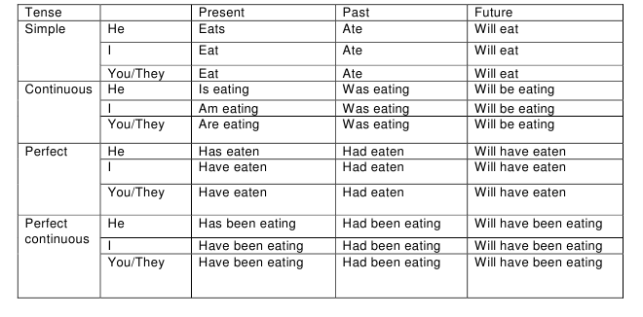 c. Prepare your Bio-data/Resume
d. Do the mail merge operation for sending applications to many companies with your resume
MS EXCEL
1.Create a worksheet in Excel for a company:
a. Copy, Move and Merge the cells
b. Adding Comments
c.Adding, Deleting the cells, Rows and Columns
d. Hiding and Unhiding the columns, Rows and gridlines.

2.Using formula and functions prepare worksheet for storing subject marks of ten students
and perform the following:
a. Calculate the student wise total and average
b. Calculate the subject wise total and average
c. Calculate the overall percentage and also individual percentage of the student.
3. Create Bar Graph and Pie Chart for various data
MS Power Point
a. Create a simple presentation with atleast 5 slides to introduce your friend and include sounds in slides.
b. Create a presentation with 5 slides for the essay Astrologer’s Day by R.K Narayanan
Internet
a. Creating an E-Mail account.
b. Sending an E-Mail to a known Address
c. Viewing an E-Mail received from your friend/relative.
d. Printing an E-Mail received
e. Use of Attachment Facility
f. Use of Address Book Facility
g. Use of Sent Folder
h. Use of Save Draft Folder
i. Use of Trash Folder
j. Browse a given web-site address.
k. Search a Particular topic through a Search engine.

SEMESTER : I

Subject Code : BE 106

Subject Title : Workshop Practice
Fitting
1. Fittion
2. V - Joint
3. L - Joint
4. T - Joint
5. Half round joint
6. Dovetail Joint
7. U – Joint
8. Hexagonal – Joint
9. Step - Joint
10. Drilling and Tapping M8
11. Drilling and Tapping M10
Wiring
1. Single lamp controlled by single switch.
2. Two Lamps controlled by two independent switches.
3. Stair case Wiring
4. Fluorescent lamp circuit.
5. Circuit diagram of a fan
6. Circuit diagram of an iron box
7. Circuit diagram of a mixie
8. Soldering practice

Sheet Metal
1. Hemming
2. Seaming
3. Tray
4. Cylinder
5. Cone
6. Hopper
7. Dust Pan
8. Funnel

SEMESTER : II

Subject Code : BE 201

Subject Title : Applied Mathematics - II

Structure of the Course Content

BLOCK 1 Vector Algebra
Unit 1: Introduction
Unit 2: Vector Properties
Unit 3: Product of Vectors
Unit 4: Application of Vectors

BLOCK 2 Integral Calculus
Unit 1: Integration
Unit 2: Standard Integrals
Unit 3: Integration by parts
Unit 4: Bernoulli’s Theorem and Applications

BLOCK 3 Differentiation
Unit 1: Velocity and Acceleration
Unit 2: Tangents and Normals
Unit 3: Maxima and Minima
Unit 4: Partial differentiation

BLOCK 4 Application of Integration
Unit 1: Definite Integral.
Unit 2: Area and Volume
Unit 3: Solution of differential equations
Unit 4: Second order differential equation with constant coefficients

BLOCK 5 Probability Distributions
Unit 1: Continuous random variable
Unit 2: Discrete random variable
Unit 3: Discrete Distributions (Binomial, Poisson )
Unit 4: Continuous Distribution

Books :

1. Engineering Mathematics – Dr. M. K.Venkatraman, National Publishing Co
2.Engineering Mathematics – Dr. P.Kandasamy & Others, Schand & Co

SEMESTER : II

Subject Code : BE 202

Subject Title : Engineering Physics - II

Structure of the Course Content

BLOCK 1 Heat
Unit 1: Heat - Kinetic Theory of Gases:
Unit 2: Specific Heat
Unit 3: Isothermal Changes
Unit 4: Adiabatic Changes

BLOCK 2 Gases & Non Conversional Energy
Unit 1: Liquefaction of Gases
Unit 2: Joule Thomson Effect & Linde’s process
Unit 3: Renewable and Non-renewable sources
Unit 4: Alternate sources of Energy-

BLOCK 3 Light & Magnetism
Unit 1: Optical Instruments
Unit 2: Lasers
Unit 3: Basic definitions of Magnetism
Unit 4: Hysteresis Loop

BLOCK 4 Electricity
Unit 1: Basic laws
Unit 2: Force on a moving charge
Unit 3: Measuring Instruments
Unit 4: Heating Effect of Electric Current

BLOCK 5 Dielectric effect & Electronics
Unit 1: Chemical Effect of Electric Current
Unit 2: Capacitor
Unit 3: Semiconductors , PN Junction & Transistors
Unit 4: Logic Gates

Books :

1. Electricity and Magnetism by Srivastava, S. Chand Publishers
2. Conventional Energy Sources by G. D. Rai, Khanna Publishers

SEMESTER : II

Subject Code : BE 203

Subject Title : Applied Chemistry - II

Structure of the Course Content

BLOCK 1 Nuclear Chemistry
Unit 1: Radio activity and definitions
Unit 2: Half life period & Nuclear fission & fusion
Unit 3: Applications of radio active isotopes
Unit 4: Abrasives

BLOCK 2 Fuels and Refractories
Unit 1: Fuels - classification
Unit 2: Solid and Liquid Fuels
Unit 3: Gas Fuels
Unit 4: Refractories

BLOCK 3 Water Treatment
Unit 1: Water Treatment Methods
Unit 2: EDTA Method
Unit 3: Water -purification
Unit 4: Lime and manufacturing process

BLOCK 4 Plastics and Rubber
Unit 1: Thermoplastics,
Unit 2: Thermo set plastics
Unit 3: Natural rubber-
Unit 4: Synthetic rubber

BLOCK 5 Metallurgy
Unit 1: Tungsten &Titanium
Unit 2: Powder metallurgy
Unit 3: Purpose of alloying
Unit 4: Non ferrous alloys

Books :

- Jain & Jain – Engineering chemistry – Dhanpatrai & Co
2. Uppal– Engineering Chemistry– Khanna publishers

SEMESTER : II

Subject Code : BE 204

Subject Title : Engineering Graphics

Structure of the Course Content

BLOCK 1 Drawing Office Practice
Unit 1: Basics of Engg Drawing
Unit 2: Dimensioning
Unit 3: Scales
Unit 4: Geometrical Constructions, conics and geometrical curves

BLOCK 2 Projection
Unit 1: Orthographic Projection
Unit 2: Projection of simple solids
Unit 3: Section of Solids
Unit 4: Half & Full Sectioning

BLOCK 3 Pictorial drawings
Unit 1: Introduction
Unit 2: Isometric Drawings
Unit 3: Conversion of orthographic views

BLOCK 4 Development of Surfaces:
Unit 1: Cube, Cylinder
Unit 2: Prism
Unit 3: Pyramids
Unit 4: Tee and Elbow

BLOCK 5 AutoCAD
Unit 1: Introduction
Unit 2: AutoCAD commands
Unit 3: Drawing -line, circle, arc, polygon,
Unit 4: Drawing - ellipse, rectangle

Books :

1."Engineering Drawing" By KR Gopalakrishnan, Dhanalakshmi publishers
2. A Book on AutoCad Release 2007

Drawing Pratices

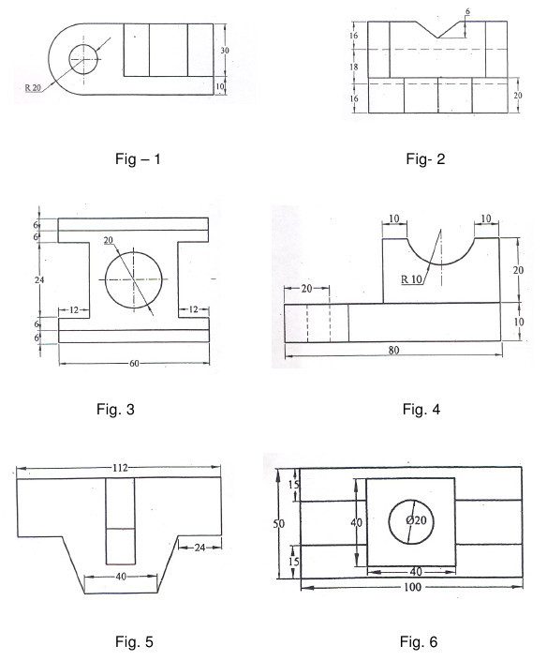
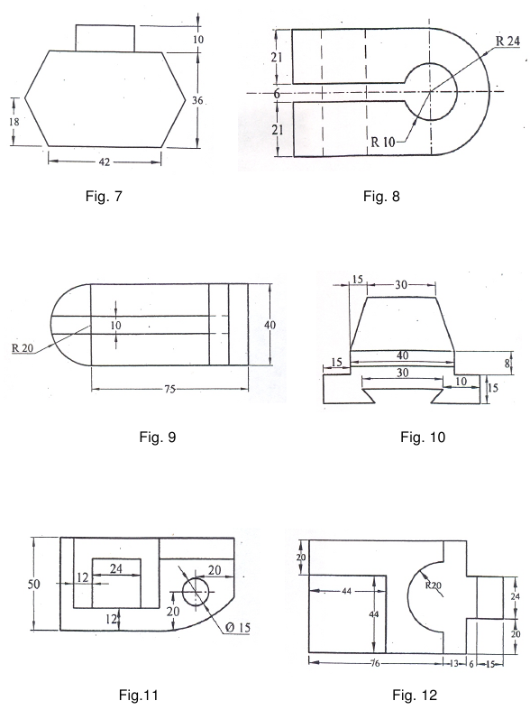

SEMESTER : II

Subject Code : BE 205

Subject Title : Engineering Physics Lab

List of Experiments

1 VERNIER CALIPERS - To find the volumes of the solid cylinder and hollow cylinder using vernier callipers.

2 SCREW GAUGE – To find the thickness of (a) glass plate (b) given sphere using screw gauge. Hence calculate the volume of the glass plate and the sphere.

3 SIMPLE PENDULUM – To find the acceleration due to gravity in the laboratory, using simple pendulum. Calculate the acceleration due to gravity, by L–T² graph.

4 CONCURRENT FORCES -To verify the parallelogram law of forces and Lami’s theorem.

5 COPLANAR – PARALLEL FORCES – To verify the conditions of the Co-planar parallel forces.

6 TORSION PENDULUM – To find the rigidity modulus of the thin wire and moment of inertia of the disc by using symmetric masses.

7 COMPARISON OF VISCOSITIES – To compare the coefficient of viscosities of two liquids by capillary flow method.

8 VISCOSITY OF A HIGHLY VISCOUS LIQUID – To find the coefficient of viscosity of a highly viscous liquid.

9 SURFACE TENSION:To find the surface tension of the given liquid by capillary rise method

10 YOUNG’S MODULUS – To find the young’s modulus of the material of the given metre scale.

11 SPECTROMETER – 1. To find the angle of the prism.

12 SPECTROMETER – 2. To find the refractive index of the material of the prism.

13 DEFLECTION MAGNETOMETER – To compare the magnetic moments of two given magnets by (a) Equal distance method and (b) Null method.

14 SONO METER – To find the frequency of the given tuning fork.

15 JOULE’S CALORIMETER – To determine the specific heat capacity of the given liquid.

16 COPPER VOLTAMETER – To determine electro – chemical – equivalent of copper.

17 OHM’S LAW – To determine the resistance of two given coils of wire using Ohm’s law. Also verify the laws of resistances.

18 POTENTIO METER – To compare the e.m.fs of two given cells.

19 PN JUNCTION DIODE – For the given semiconductor diode draw (a) Forward bias (b) Reverse bias characteristic curves.

20 SOLAR CELLS – V. I. Characteristics.

SEMESTER : II

Subject Code : BE 206

Subject Title : Applied Chemistry Lab

List of Experiments

- Qualitative Analysis

Acid radicals : Chloride, Carbonate, Sulphate, Nitrate

Basic radicals: Lead, Cadmium, Copper, Aluminium, Zinc, Calcium, Magnesium, Ammonium

Identification of acid and basic radicals in
1. Lime Stone (Calcium Carbonate)
2. Pollutant (Lead nitrate or Cadmium Carbonate)
3. Fertilizer(Ammonium sulphate)
4. Electrolyte(Ammonium Chloride)
5. Fungicide(Copper sulphate)
6. Coagulant(Aluminium Sulphate)
7. Mordant(Zinc Sulphate)
8. Gypsum(Calcium Sulphate)
9. Epsum(Magnesium Sulphate)
10. Analysis of an Effluent (containing pollutants like Lead, Cadmium, Zinc, Copper).Students may be given above four pollutants , in four separate test tubes in solution form and asked to report metallic pollutants with procedure (Basic Radical Analysis Procedure) and their harmful effects.

2. VOLUMETRIC ANALYSIS (DOUBLE TITRATIONS)
ACIDIMETRYAND ALKALIMETRY
1. Estimation of Hydrochloric acid
2. Estimation of Sodium Hydroxide
3. Estimation of Sodium Carbonate
4. Comparison of Strengths of two bases

PERMANGANIMETRY
5. Estimation of Ferrous Ammonium Sulphate
6. Estimation of Ferrous Sulphate
7. Comparison of Potassium Permanganate.
WATER ANALYSIS
8. Estimation of Total Hardness by EDTA method.
9. Calculation of pH of four sample solutions and calculation of H+ Ion concentration for a particular sample solution.

SEMESTER : III

Subject Code : ME 301

Subject Title : Engineering Mechanics

Structure of the Course Content

BLOCK 1 Mechanical Properties of Materials
Unit 1: Basic Definitions
Unit 2: Stress
Unit 3: Strain
Unit 4: Stress-Strain Calculations

BLOCK 2 Geometrical Properties of Sections
Unit 1: Basic Definitions
Unit 2: Moment of Inertia
Unit 3: Thin cylinders
Unit 4: Thin Spherical Shells

BLOCK 3 Theory of Simple Bending
Unit 1: Shear Force
Unit 2: Bending Moment
Unit 3: Cantilever
Unit 4: Simple Bending

BLOCK 4 Torsion and Springs
Unit 1: Theory of Torsion
Unit 2: Tortional Rigidity
Unit 3: Hollow Shaft
Unit 4: Springs

BLOCK 5 Deflection
Unit 1: Beams
Unit 2: Friction
Unit 3: Gear Drives
Unit 4: Belt Drives

Books :
- Applied Mechanics by A.K.Upadhyay, Charotar Publishers
- Strength of Materials by R.S.Khurmi, S.Chand & Co

SEMESTER : III

Subject Code : ME 302

Subject Title : Manufacturing Technology - I

Structure of the Course Content

BLOCK 1 Foundry
Unit 1: Patterns
Unit 2: Moulding
Unit 3: Casting
Unit 4: Furnace

BLOCK 2 Forging and Welding
Unit 1: Hot Working operation
Unit 2: Welding
Unit 3: Types of Welding
Unit 4: Types of Testing

BLOCK 3 Powder Metallurgy and Heat Treatment
Unit 1: Methods of Manufacturing
Unit 2: Metallurgy
Unit 3: Heat Treatment
Unit 4: Hardening

BLOCK 4 Lathe
Unit 1: Simple Lathe
Unit 2: Semi Automatic Lathe
Unit 3: Fully Automatic Lathe
Unit 4: Multi Spindle Automatic Lathe

BLOCK 5 Metrology
Unit 1: Measuring Instruments
Unit 2: Marking Instruments
Unit 3: Comparators
Unit 4: Gauges

Books :
- R.S. Khurmi & J.K. Gupta, A Text Book of workshop Technology, Edn.2, S.Chand & Co., New Delhi
- Begeman, Manufacturing Process, Edn.-5, TMC, New Delhi.

SEMESTER : III

Subject Code : ME 303

Subject Title : Fluid Mechanics

Structure of the Course Content

BLOCK 1 Properties of Fluids
Unit 1: Basic Definition
Unit 2: Pressure measurement
Unit 3: Mechanical Gauges
Unit 4: Diaphragm Pressure gauge

BLOCK 2 Flow of Fluids
Unit 1: Type of Fluids
Unit 2: Bernoulli’s Theorem
Unit 3: Orifice Meter
Unit 4: Venturi Meter

BLOCK 3 Jets and Pumps
Unit 1: Impact of Jets
Unit 2: Turbine
Unit 3: Types Turbines
Unit 4: Pumps

BLOCK 4 Pneumatic Systems
Unit 1: Basics of Pneumatic systems
Unit 2: Flow Control Valve
Unit 3: FRL Unit
Unit 4: Application of Pneumatic Systems

BLOCK 5 Hydraulic Systems
Unit 1: Basics of Hydraulic Systems
Unit 2: Accumulator
Unit 3: Fluid Power Pump
Unit 4: Application of Hydraulic Systems

Books :
- .S. Khurmi, A Text Book of Hydraulics, Fluid Mechanics, S.Chand & Co, New Delhi
- R.K.Rajput, A Text Book of Hydraulics

SEMESTER : III

Subject Code : ME 304

Subject Title : Machine Drawing

Structure of the Course Content

BLOCK 1 Section Views
Unit 1: Need Sectioning
Unit 2: Hatching
Unit 3: Half Sectioning and full sectioning
Unit 4: Removed and offset sections

BLOCK 2 Limits, Fits and Tolerances
Unit 1: Basic Definitions
Unit 2: Limits
Unit 3: Fits
Unit 4: Tolerances

BLOCK 3 Keys and Surface finish
Unit 1: Basic Definitions
Unit 2: Types of Keys
Unit 3: Design of shaft and keys
Unit 4: Indication of surface roughness

BLOCK 4 Threads and Fasteners
Unit 1: Basic Definition
Unit 2: Types of Threads
Unit 3: Types of Bolts and nuts
Unit 4: Types of Rivets

BLOCK 5 CAD Drawings
Unit 1: AutoCAD Theory
Unit 2: Sleeve and Cotter Joint
Unit 3: Machine Vice
Unit 4: Screw Jack

Books :
- N.D.Bhatt, Machine Drawing, Edn.37, Charotar Publishing House
- R.C.Parkinson, Engineering Drawing Published by English University Press, London

SEMESTER : III

Subject Code : ME 305

Subject Title : Engineering Mechanics Lab

Laboratory Experiments :

- Test on Ductile Materials
- Hardness Test
- Torsion test
- Bending and deflection tests
- Impact test
- Tests on springs of circular section
- Shear test
- Verifying the Bernoulli’s Theorem
- Determination of Coefficient of discharge of a Venturimeter
- Determination of Coefficient of discharge of a Orificemeter
- Performance test on a reciprocating pump
- Performance test on a centrifugal pump
- Performance test on an impulse turbine
- Performance test on a reaction turbine

SEMESTER : III

Subject Code : ME 306

Subject Title : Workshop –I

Structure of the Course Content

Smithy :

Exercises:

1. Round rod to hexagonal rod
2. Round rod to square rod
3. Round rod to square headed bolt
4. Round rod to ‘S’ Shape
5. Round rod to flat with 25mm

Foundry :

Exercises:

Preparation of sand mould:
6. Solid pattern
a. Stepped Pulley
b. Bearing top
c. Gear Wheel
d. T-pipe
7. Split pattern
a. Bent Pipe
b. Dumbles
8. Loose Piece Pattern- Dowtail
9. Cylindrical core making
10. Melting and casting

Welding :

Exercises:
11. Arc welding
a. Lap joint (Material: 25mm x 3mm Ms Flat )
b. Butt joint (Material: 25mm x 6mm Ms Flat )
c. T-joint (Material: 25mm x 3mm Ms Flat )
d. Corner joint (Material: 25mm x 3mm Ms Flat )
12. Gas Welding
a. Lap joint (Material: 25mm x 3mm Ms Flat )
b. Butt Joint (Material: 25mm x 6mm Ms Flat )
13. Gas cutting: Profile cutting.
14. Spot welding-Lap joint(18/20swg)
15. Demonstration of Soldering and brazing

SEMESTER : IV

Subject Code : ME 401

Subject Title : Thermodynamics

Structure of the Course Content

BLOCK 1 Thermodynamics and Expansion of Gases
Unit 1: Basic Definitions
Unit 2: Steam Properties
Unit 3: Gas Properties
Unit 4: Law of Perfect Gases

BLOCK 2 Steady flow energy equation and Air Cycles
Unit 1: Steady flow system
Unit 2: Steam Boilers
Unit 3: Air Cycles
Unit 4: P-V Diagram

BLOCK 3 Internal Combustion engines
Unit 1: Diesel Engines
Unit 2: Petrol Engines
Unit 3: Ignition Systems
Unit 4: Lubrication Systems

BLOCK 4 Fuels & Performance of I.C.Engines
Unit 1: Classification of fuels
Unit 2: Performance of IC Engines
Unit 3: Break power calculation
Unit 4: Morse test

BLOCK 5 Air Compressors
Unit 1: Basic Definition
Unit 2: Types of Compressor
Unit 3: Working Principle of Compressor
Unit 4: Problems

Books :
- R.S.Khurmi and J.K. Gupta, Thermal Engineering, Edn. 18, published by S.Chand & Co
- P.K.Nag, Applied Thermodynamics, Edn.24, TMC, New Delhi.

SEMESTER : IV

Subject Code : ME 402

Subject Title : Manufacturing Technology

Structure of the Course Content

BLOCK 1 Planer, Shaper and Slotter
Unit 1: Planer
Unit 2: Shaper
Unit 3: Slotter
Unit 4: Jig and fixtures

BLOCK 2 Drilling Machines and Milling Machines
Unit 1: Types of Drilling Machines
Unit 2: Types of Drilling Operations
Unit 3: Types of Milling Machines
Unit 4: Types of Milling Operations

BLOCK 3 Grinding, Broaching & Boring
Unit 1: Types of Grinding Machines
Unit 2: Principle and Operation of Grinding Machines
Unit 3: Broaching
Unit 4: Boring

BLOCK 4 Gear Manufacturing
Unit 1: Gear Manufacturing in Milling operation
Unit 2: Gear Manufacturing in Shaping operation
Unit 3: Milling Procedure for Spur Gear
Unit 4: Milling Procedure for Helical & bevel gears

BLOCK 5 Jigs and Fixtures and Press works
Unit 1: Jigs
Unit 2: Fixtures
Unit 3: Mechanical Press
Unit 4: Hydraulic Press

Books :
- Hajra Choudry & Battacharya, Elements of Workshop Technology-Vol-I & II, Edn. 11, Mumbai.
- Jain & Gupta, Production Technology, Khanna Publishers, New Delhi.

SEMESTER : IV

Subject Code : ME 403

Subject Title : Electrical & Electronics Engineering

Structure of the Course Content

BLOCK 1 DC Circuits and Batteries
Unit 1: Basic Laws
Unit 2: Series, Parallel connections
Unit 3: Batteries
Unit 4: Types of Batteries

BLOCK 2 DC Machines
Unit 1: DC Generator
Unit 2: DC Motors
Unit 3: Types of Starters
Unit 4: Applications of DC Machines

BLOCK 3 AC Machines
Unit 1: Transformers
Unit 2: AC Motors
Unit 3: Types of Starters
Unit 4: Applications of AC Motors

BLOCK 4 Electronic Devices
Unit 1: Semi Conductor Theory
Unit 2: Diode
Unit 3: Transistor
Unit 4: Thyristors

BLOCK 5 Electrical Safety
Unit 1: Earthing
Unit 2: Types of Earthing
Unit 3: Electric Shock
Unit 4: Safety precautions

Books :
- B.L.Theraja, Fundaments of Electrical and Electronics Engineering, S.Chand & Co.
- T.Thiyagarajan, Fundamentals of Electrical and Electronics Engineering, Scitech Publications.

SEMESTER : IV

Subject Code : ME 404

Subject Title : Refrigeration and Air Conditioning

Structure of the Course Content

BLOCK 1 Refrigeration System & refrigeration equipments
Unit 1: Basic Definition
Unit 2: Refrigeration Systems
Unit 3: Refrigeration Equipments
Unit 4: Problems

BLOCK 2 Vapour Compression and Absorption Systems
Unit 1: Vapour Compression Systems
Unit 2: Heat Exchangers
Unit 3: Vapour Absorption Refrigeration System
Unit 4: Electrolux System

BLOCK 3 Refrigeration Flow Controls & Refrigerants
Unit 1: Refrigeration flow control
Unit 2: Refrigerants
Unit 3: Lubricants
Unit 4: Applications of Refrigeration

BLOCK 4 Psychrometry and Comport Air conditioning
Unit 1: Basic Definitions
Unit 2: Psychometric Processes
Unit 3: Enthalpy calculation
Unit 4: Problems

BLOCK 5 Air Conditioning Systems and Cooling load calculations
Unit 1: Air Conditioning Systems
Unit 2: Fan and Blowers
Unit 3: Insulating Materials
Unit 4: Cooling load calculations

Books :
- P.L.Ballaney, Refrigeration and Air Conditioning, Khanna Publishers, New Delhi.
- V.K.Jain, Refrigeration and air conditioning.

SEMESTER : IV

Subject Code : ME 405

Subject Title : Thermodynamics Lab

Laboratory Experiments :

1. Determining flash and fire points of the given oil using open cup apparatus.
2. Determining flash and fire points of the given oil using close cup apparatus.
3. Determining the absolute viscosity of the given lubricating oil using Redwood
viscometer.
4. Determining the absolute viscosity of the given lubricating oil using Saybolt
viscometer.
5. Valve timing diagram of four-stroke cycle petrol engine.
6. Valve timing diagram of four-stroke cycle diesel engine.
7. Port timing diagram of two-stroke cycle petrol engine.
8 Load test (Performance Test) on petrol engine.
9 Load test (Performance Test) on diesel engine.
10. Morse test on multicylinder petrol engine.
11. Heat balance sheet on I.C engine.
12. Emission test for petrol / diesel engine.
13. Volumetric efficiency of air compressor.

SEMESTER : IV

Subject Code : ME 406

Subject Title : Workshop –II

Structure of the Course Content

Syllabus:

1. Introduction of safety in operating machines.
2. Introduction to lathe, drilling machine & shaping machine and its parts.
3. Introduction to work holding devices and tool holding devices.
4. Types of tools used in lathe work, drilling & shaping.
5. Types of measuring instruments and their uses.
6. Setting of work and tools.
7. Operation of lathe, drilling & shaping.
8. Practice on a lathe, drilling and shaping machine

Note: The dimensions may be modified according to the materials specified.

Enclosure: Sketches of Lathe, drilling & shaping Exercises.

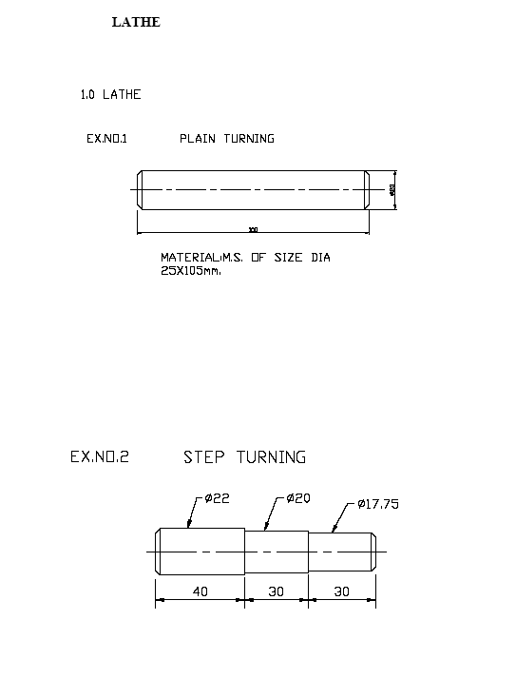

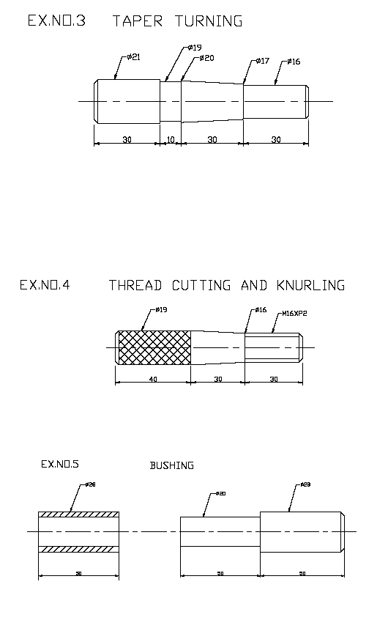

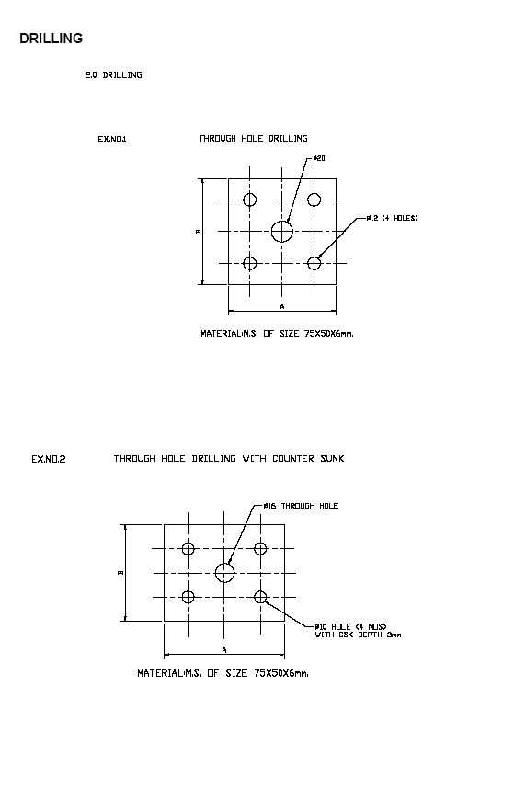

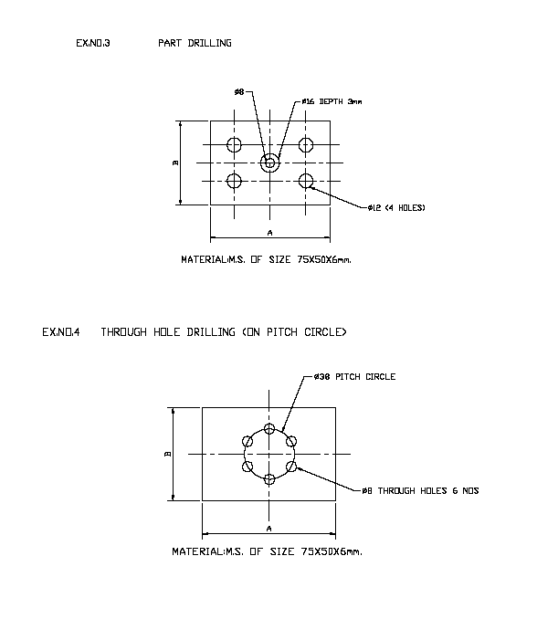

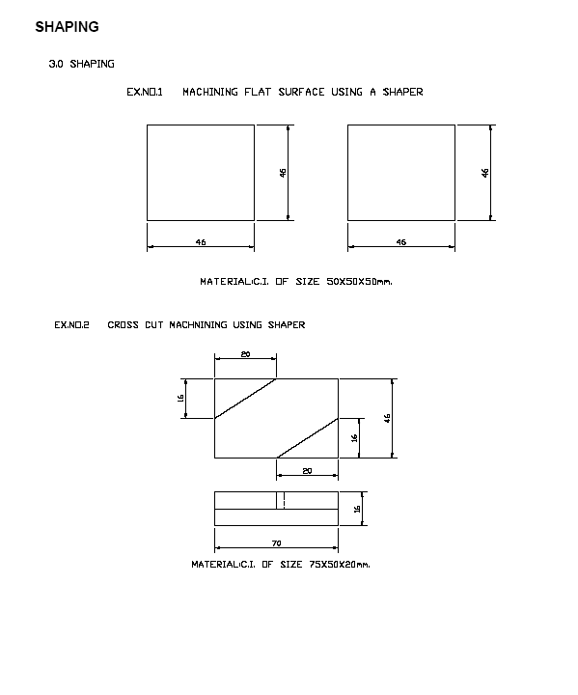

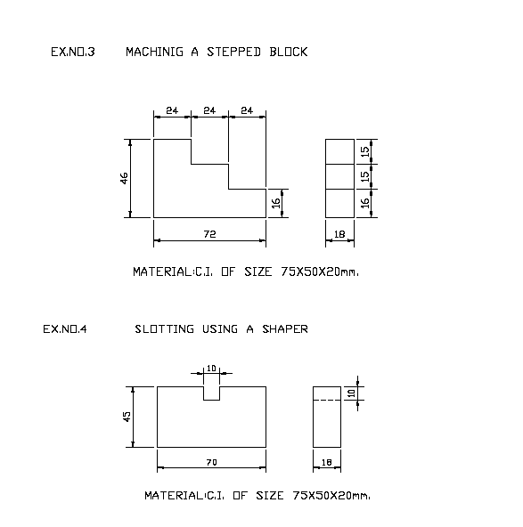

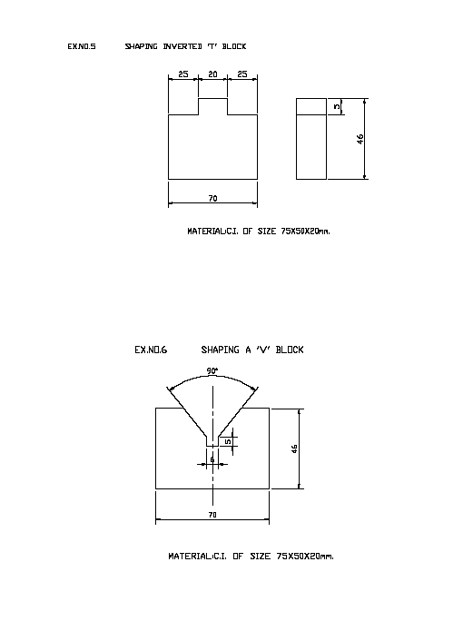

SEMESTER : V

Subject Code : ME 501

Subject Title : Design of Machine Elements

Structure of the Course Content

BLOCK 1 Design of shafts
Unit 1: Selection of Materials
Unit 2: Design of shaft
Unit 3: Maximum bending movement
Unit 4: Twisting movement

BLOCK 2 Design of Bolt
Unit 1: Selection of Materials
Unit 2: Design of Bolt
Unit 3: Design of pin and key
Unit 4: Design of cotter joint and couplings

BLOCK 3 Design of Belts
Unit 1: Selection of Materials
Unit 2: Design of flat belts
Unit 3: Design of V belts
Unit 4: Power Design of V-belt drives

BLOCK 4 Design of Bearings
Unit 1: Selection of Materials
Unit 2: Design of ball and radial bearing
Unit 3: Design of roller bearing
Unit 4: Design of Cylindrical bearing

BLOCK 5 Design of Levers and gears
Unit 1: Selection of Materials
Unit 2: Design of Levers
Unit 3: Design of gears
Unit 4: Design of spur gears

Books :
  - Pandya & Shah, Machine Design, Edn. 1995 Charotar Publishing House.
  - R.S.Khurmi & J K Gupta, A text book of machine design, Edn. 18, New Delhi.

SEMESTER : V

Subject Code : ME 502

Subject Title : Thermal Engineering

Structure of the Course Content

BLOCK 1 Steam and Expansions of steam
Unit 1: Basic definitions
Unit 2: Enthalpy and Entrophy
Unit 3: Types of Steam
Unit 4: Problems using mollier chart

BLOCK 2 Steam Boilers and Performance of Boilers
Unit 1: Classification of Boilers
Unit 2: Boilers mounting and accessories
Unit 3: Performance of Boilers
Unit 4: Problems

BLOCK 3 Thermal Power Plant
Unit 1: Layout of thermal power plant
Unit 2: Pollution effects in thermal power plant
Unit 3: Stream turbine
Unit 4: Problems

BLOCK 4 Nuclear Power Plant
Unit 1: Layout of Nuclear power plant
Unit 2: Nuclear fuels
Unit 3: Moderator
Unit 4: Safety precautions in Nuclear Power Plant

BLOCK 5 Energy Engineering and Management
Unit 1: Basic Definitions
Unit 2: Energy Engineering
Unit 3: Conventional sources
Unit 4: Non-conventional sources

Books :
1. R.K.Rajput, Thermal Engineering
2. R.S.Khurmi & J K Gupta, Thermal Engineering, Edn. 18, New Delhi.

SEMESTER : V

Subject Code : ME 503

Subject Title : Metrology

Structure of the Course Content

BLOCK 1 Standards of measurements
Unit 1: Introduction to Metrology
Unit 2: Objectives of Metrology
Unit 3: Classification of standards
Unit 4: Classification of measuring instruments

BLOCK 2 Linear and Angular Measurements
Unit 1: Vernier Calipers and gauges
Unit 2: Bevel Protectors
Unit 3: Sine bar
Unit 4: Taper measurement

BLOCK 3 Measurement of threads and gears
Unit 1: Screw thread gauges
Unit 2: Gear tooth vernier
Unit 3: Measurement of tooth profile
Unit 4: Alignment of gears

BLOCK 4 Measurement of Surface finish
Unit 1: BIS Methods of Measuring surface finish
Unit 2: Comparison methods of surface finish
Unit 3: Inspection
Unit 4: Surface Photographs

BLOCK 5 Comparators
Unit 1: Types Comparators
Unit 2: Mechanical Comparators
Unit 3: Electrical Comparators
Unit 4: Electronics Comparators

Books :
- R.K.Rajput, Engineering Metrology & Instrumentation, 4th Edition 2004, S.K.
Kataria & Sons, New Delhi.
2. M.Mahajan, Engineering Metrology, 2005, Dhanpatrai & Co, New Delhi.

SEMESTER : V

Subject Code : ME 504

Subject Title : Mechatronics

Structure of the Course Content

BLOCK 1 Introduction, sensors & transducers
Unit 1: Introduction to Mechatronics
Unit 2: Control Systems
Unit 3: Displacement, position & Proximity Sensors
Unit 4: Velocity and Motion Sensors

BLOCK 2 Actuation Systems
Unit 1: Mechanical Actuation Systems
Unit 2: Electrical Actuation Systems
Unit 3: Pneumtaic Actuation Systems
Unit 4: Hydraulic Actuation Systems

BLOCK 3 Basic System Models, I/O systems
Unit 1: Mathematical Model
Unit 2: Mechanical and Electrical systems building blocks
Unit 3: Hydro and pneumatic Systems building blocks
Unit 4: Interfacing I/O ports

BLOCK 4 Programmable Logic Controller
Unit 1: Basic Block diagram and Structure of PLC
Unit 2: I/O processing
Unit 3: Ladder diagram
Unit 4: Selection PLC

BLOCK 5 Design Examples
Unit 1: Design Process stages
Unit 2: Traditional Vs Mechatronics designs
Unit 3: Case studies of Car Park barrier
Unit 4: Case studies of Automatic washing machine

Books :
- R.K.Rajput, A Text Book of Mechatronics, 1st Edn. 2007, S.Chand & co
- HMT, Mechatronics, 1st Edition 1998, TMC, New Delhi.

SEMESTER : V

Subject Code : ME 505

Subject Title : Metrology Lab

Exercises:

I. Linear Measurements:

1. Determination of the thickness of ground MS flat to an accuracy of 0.02mm using vernier
caliper.
2. Determination of the diameter and length of a turned cylindrical (turned in lable exercise)
to an accuracy of 0.02mm using vernier caliper.
3. Determination of the inside diameter of a bush component to an accuracy off 0.02 using
vernier caliper.
4. Determination of diameter of a cylindrical component to an accuracy 0f 0.01mm using
micrometer and check the result with digital micrometer
5. Determination of inside diameter of the bore of a bush cylindrical component to an
accuracy of 0.01mm using inside micrometer.
6. Determine the heights of gauge blocks or parallel bars to accuracy of 0.02mm using
vernier height gauge and check the result with digital vernier height gauge.
7. Determine the depth of a blind bore component to an accuracy of 0.02mm using vernier
depth gauge.
8. Determine the thickness of ground MS plates using slip gauges

I. Angular Measurements:

9. Determination of angle of v-blocks, dovetails in mechanical components using universal
bevel protractor.
10. Determination of angle of machined surfaces of components using sine bar with slip
gauges.
11. Measurement of V-Thread dimensions.
12. Measurement of spur gear tooth dimensions.

SEMESTER : V

Subject Code : ME 506

Subject Title : Workshop- III

Syllabus:

1. Introduction to planning machine and its parts.
2. Introduction to slotting machine and its parts.
3. Introduction to milling machine and its parts.
4. Introduction to grinding machine and its parts.
5. Introduction to turret and capstan lathe.
6. Introduction to work holding devices.
7. Types of tools used in planning and slotting machines.
8. Types of cutter used in milling machine.
9. Types of grinding wheels used in grinding machines.
10.Types of tools used in turret and capstan lathes.
11.Setting of work, tools and cutters in planning, slotting, milling and grinding machines.
12.Operation performed in planning, slotting, milling and grinding machines.
13.Operation of planning, slotting, milling, grinding, capstan and turret machines.

Enclosure : Sketches for Exercises

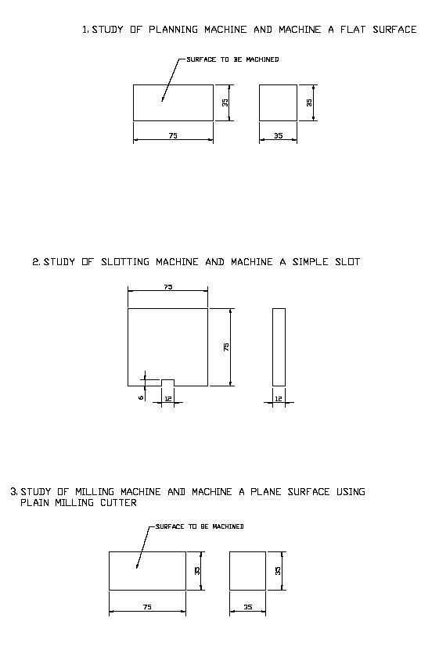

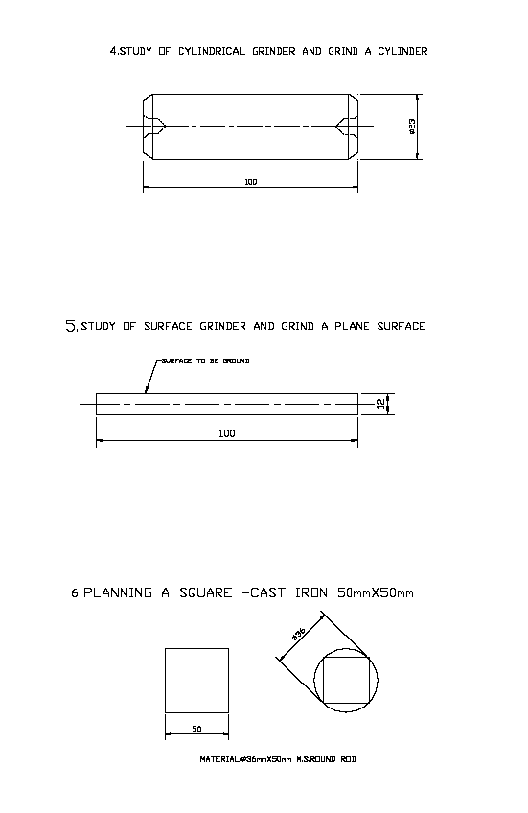

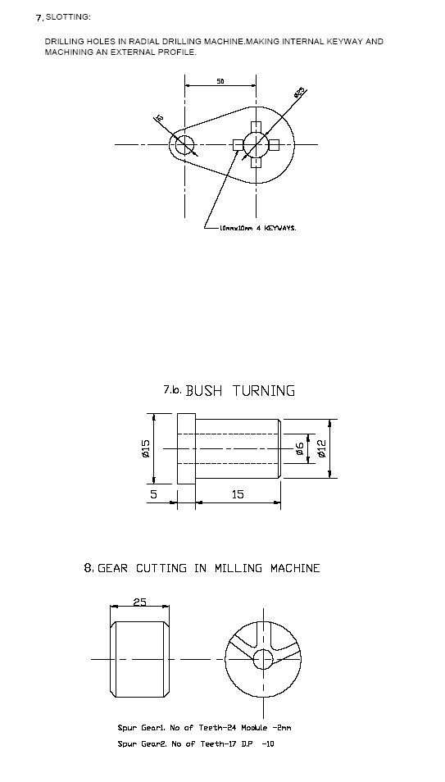

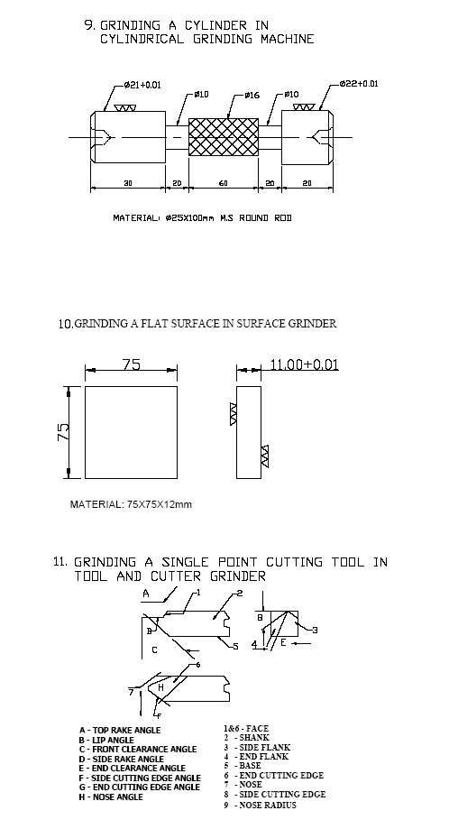

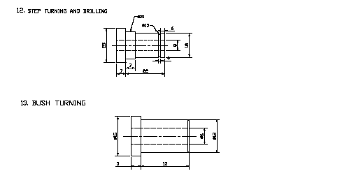

SEMESTER : VI

Subject Code : ME 601

Subject Title : Industrial Engineering and Management

Structure of the Course Content

BLOCK 1 Plant Engineering and Plant Safety
Unit 1: Plant Layout
Unit 2: Plant Maintenance
Unit 3: Plant Safety
Unit 4: Plant Safety rules

BLOCK 2 Work study, Method study and work Measurement
Unit 1: Work study
Unit 2: Method study
Unit 3: String and flow diagram
Unit 4: Work Measurement

BLOCK 3 Production Planning and Quality Control
Unit 1: Production Planning
Unit 2: Critical Path Method
Unit 3: Quality Control
Unit 4: Types of measurements

BLOCK 4 Principles of Management and Personnel Management
Unit 1: Administration and Organisation
Unit 2: Leadership and Motivation
Unit 3: Total Quality Management
Unit 4: Personnel Management

BLOCK 5 Financial Management and Material Management
Unit 1: Fixed and Working capital
Unit 2: Equity shares
Unit 3: Depreciation
Unit 4: Material Management

Books :
- O.P.Khanna, Industrial Engineering and Management, Rev. Edition-2004,
Dhanpat Rai Publications (P)Ltd, New Delhi.
- Joseph L.Masse, Essentials of Management, 4th Edition, Prentice Hall of India, New Delhi.

SEMESTER : VI

Subject Code : ME 602

Subject Title : CAD/CAM

Structure of the Course Content

BLOCK 1 Computer Aided Design
Unit 1: CAD Definition
Unit 2: I/O Devices
Unit 3: Memory
Unit 4: Types of CAD systems

BLOCK 2 Computer Aided Manufacturing
Unit 1: CAM Definition
Unit 2: Integrated CAD/CAM Organisation
Unit 3: Master Production schedule
Unit 4: Product Development cycle

BLOCK 3 CNC Machines
Unit 1: Numerical Control
Unit 2: NC, CNC and adaptive control systems
Unit 3: Types of CNC Machines
Unit 4: CNC EDA Machines

BLOCK 4 CNC components and Part programming
Unit 1: Drives
Unit 2: Actuating systems
Unit 3: CNC programming procedures
Unit 4: CAD Models

BLOCK 5 GT – FMS – CIM –AGV and Robotic
Unit 1: FMS
Unit 2: CIM
Unit 3: AGV
Unit 4: Robotic

Books :
- CAD/CAM/CIM, R.Radhakrishnan, S.Subramanian, V.Raju, 2nd, 2003, New Age
International Pvt Ltd..
2. CAD/CAM, Mikell P.Groover, Emory Zimmers Jr. Indian Reprint Oct 1993, Prantice
Hall of India

SEMESTER : VI

Subject Code : ME 603

Subject Title : Automobile Technology

Structure of the Course Content

BLOCK 1 Automotive Engines
Unit 1: Basics Engine Component
Unit 2: Construction of Automotive Engines
Unit 3: Stages of Combustion
Unit 4: Cooling and Lubrication systems

BLOCK 2 Fuel and Fuel Feed Systems
Unit 1: Ideal Petrol
Unit 2: Natural Gas and Bio Gas
Unit 3: Layout of fuel feed system in petrol engine
Unit 4: Layout of fuel feed system in Diesel Engine

BLOCK 3 Transmission
Unit 1: Power Transmission Systems
Unit 2: Gear Box Construction
Unit 3: Shaft Construction
Unit 4: Differential Construction

BLOCK 4 Automotive Chassis
Unit 1: Front Axle
Unit 2: Steering System
Unit 3: Suspension System
Unit 4: Brake Systems

BLOCK 5 Automobile Electrical Equipment
Unit 1: Lead acid Battery
Unit 2: Starter Motor
Unit 3: Drive Mechanism
Unit 4: Ignition Systems

Books :
- Automobile Transmission and Power Systems, William.H.Grouse.

2. Narang. G.B.S..,”Automobile Engineering”, Khanna Publishers, New Delhi.

SEMESTER : VI
Subject Code : ME 604
Subject Title : CAD/CAM lab

PART-1 CAD Practical

3D CAD Drawing – Solid Modeling & Lisp Programming

1. Predefined 3D objects – converting 2D plan into a 3D model – 3Dmesh – 3Dface - 3Dpoly -creating surfaces – Rulsurf – Revsurf – Tabsurf – Edgesurf – isolines -3DView – viewports –Vpoint – hide – dview – modelspace - paper space.

2. 3D solid primitives - creating region – pedit – extrude – revolve - combining object – union –subtract – intersect – Align – Fillet – chamfer - Advanced 3D editing techniques – align - 3D array–Mirror 3D - Rotate3D.

3. Working with UCS – 3D coordinate system – DDUCS – Plan – UCS icon

4. Solid Rendering – material attaching and detaching – shade with color – slice and sectioning –script – 3D orbit – calculating mass properties

5. Developing LISP program – constructing a list – input/output functions – control structures -arithmetic operations – trigonometric functions – special functions.

3D solid modeling and LISP programming practice
i) Geneva Mechanism
ii) Cast Iron Block
iii) Bearing Block
iv) Bushed Bearing
v) Gib and Cotter joint
vi) Screw Jack
vii) Universal Coupling

Part-2 CAM Practical

Exercise practice
CNC Lathe
1. Develop a part program for step turning and simulate
2. Develop a part program for taper turning and simulate
3. Develop a part program for circular interpolation and simulate
4. Develop a part program for multiple turning operation and simulate
5. Develop a part program for thread cutting, grooving and simulate
6. Develop a part program for internal drills, boring and simulate
CNC Milling
7 Develop a part program for grooving and simulate
8. Develop a part program for drilling (canned cycle) and simulate
9. Develop a part program for mirroring with subroutines and simulate
10.Develop a part program for rectangular and circular pocketing and simulate

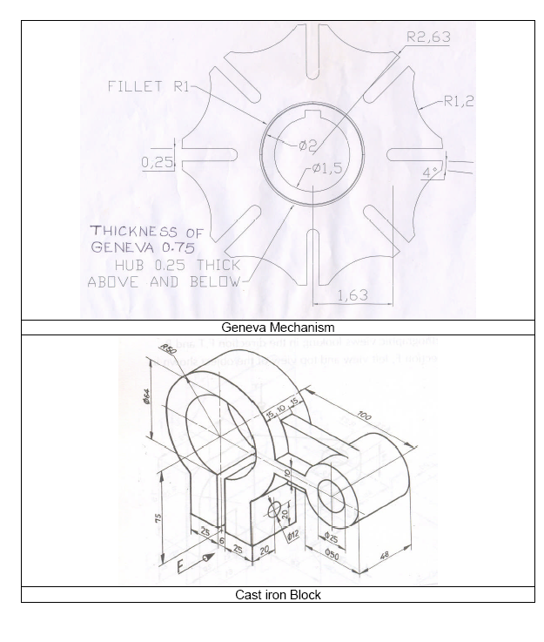

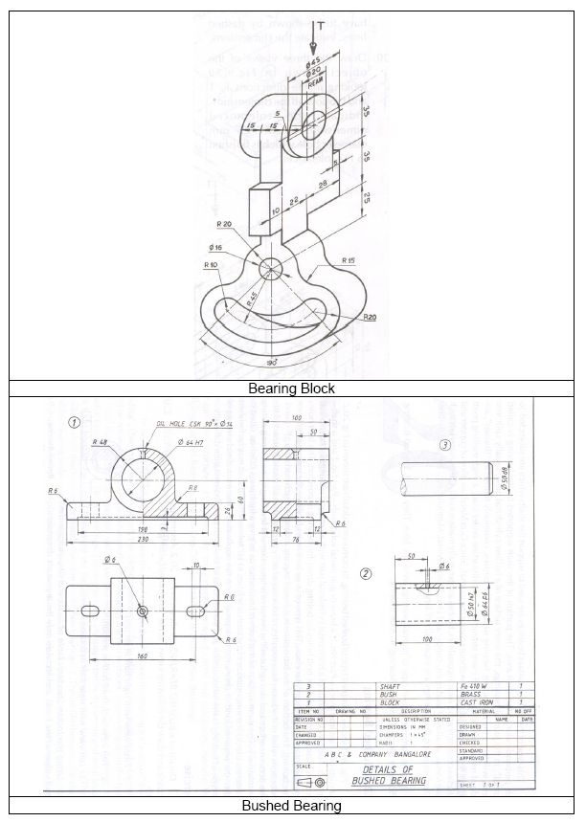

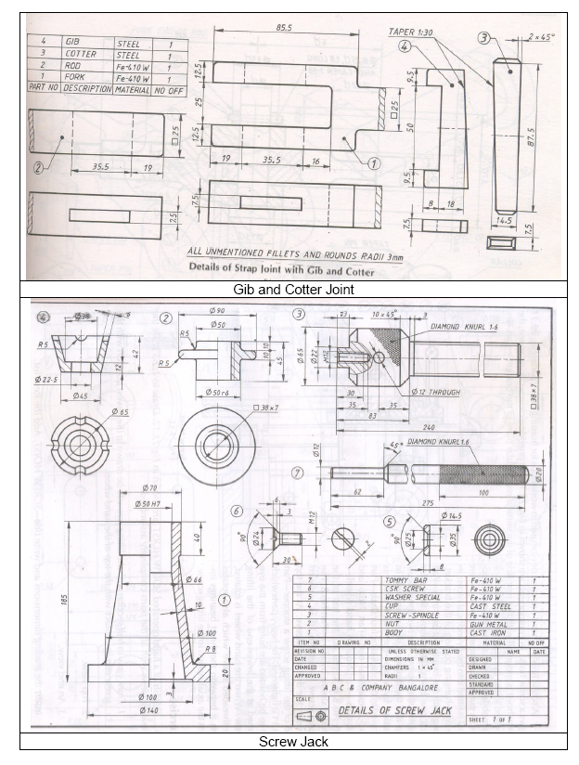

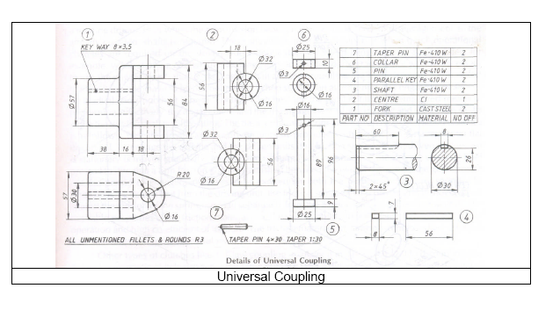

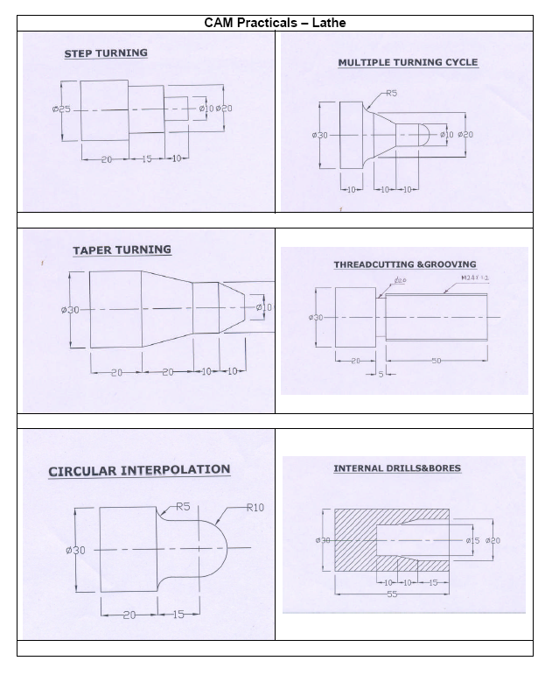

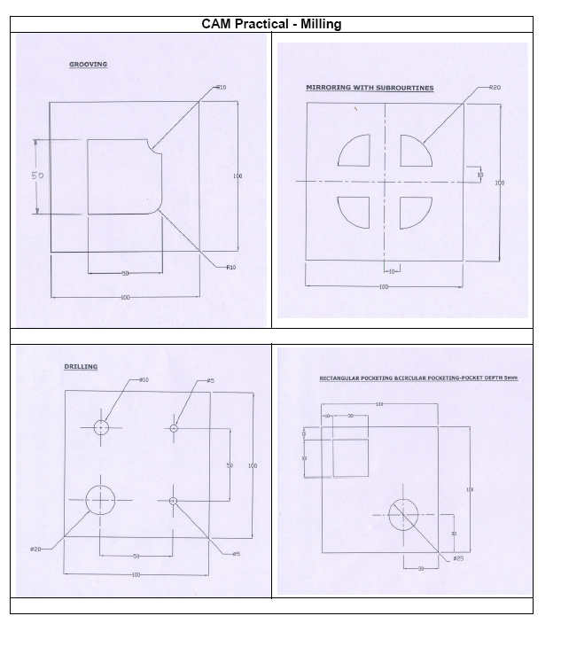

SEMESTER : VI

Subject Code : ME 605

Subject Title : Project

